**Fridge Door**

**Alarm Circuit**

**Components Required:**  
  
1. 555 timer IC – 2  
2. 5mm LDR – 1  
3. Buzzer – 1  
4. Diode (1N4001) – 1  
5. Capacitor, 47uF(Electrolytic) – 1  
6. Capacitor, 0.1uF(Ceramic) – 1   
7. Resistors (10kὨ - 1; 470kὨ -1; 150kὨ -2)  
8. Breadboard  
9. Connecting wires

**LDR (Light Dependent Resistor):**

LDR works under the principle of Photo Conductivity. The conductance of the material inside the element increases i.e., resistance decreases when light falls over it.

**555 Timer in Astable operation:**

Astable multivibrator has no stable states. The output swings between high and low based on the timing resistor and capacitor.

Here in this Fridge Door Open Alarm Circuit, we have used two 555 ICs, one for calculate the ‘Fridge door Open time duration’ after which the Buzzer should be triggered, and second 555 IC is for controlling the Buzzer beeping pattern.

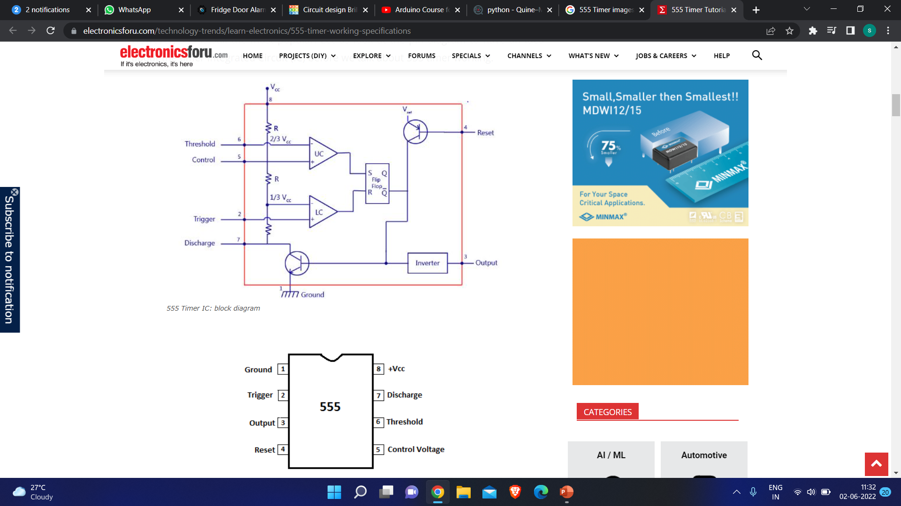

**Time Delay:-**

Time(sec) = 1.1* (R2+R3) *C1

**Time delay for Buzzer to be triggered**

R2= 150 kΩ , R3= 470 k Ω in series and C1 = 46 uF

Time delay= 1.1 * (620 kΩ ± 5%) * 47uF=30 to 34 secs

**Controlling** **Buzzer Beeping Time Period**

R4= 470 kΩ and C2= 0.1 uF

Time= 1.1 * (470 kΩ ± 5%) * 0.1uF =0.5 secs(approximately)

**CIRCUIT DIAGRAM:-**



**Working:-**

The whole circuit is powered by a 9V battery. When the fridge door is closed, it is dark and the resistance of the LDR is nearly 1MὨ as given in datasheet. When we open the Fridge, the light falls over LDR which lowers down the resistance of LDR and causing the capacitor to discharge which in this RC combination it is 30 secs. After this the output starts to oscillate and output is HIGH. Again, the capacitor charges and reaches a threshold continued by discharge of the capacitor. This continues till the LDR resistance goes high which will happen in the absence of light (door is closed).

The output becomes HIGH and LOW causing the buzzer connected to output to beep in a pattern which is combinational cause of the first timer oscillations and the second timer internal oscillation. During HIGH condition of first timer output, the second timer master reset will happen. Thus, the capacitor C2 charges and output goes LOW. In a short span the capacitor starts to discharge causes the output HIGH. Hence, the buzzer connected to output becomes pulsed beep sound.

**Advantages:-**

Elongates the life of compressor and prevents malfunction of refrigerator

Reduces CFC emission thus will help in decreasing ozone layer depletion.